Internet Café Management System
Project Documentation

Contents

📘 Internet Café Management System
📄 Project Documentation
- Project Overview ………………………………………………………………………………………………….. 1
- System Architecture ………………………………………………………………………………………………. 1
- Features …………………………………………………………………………………………………………………. 2
- Workflow / How It Work ……………………………………………………………………………………….. 3
- Technologies Used ………………………………………………………………………………………………… 3
- Charts(UI) ……………………………………………………………………………………………………………… 3
  - Admin’s Chart …………………………………………………………………………………………….. 3
  - Client’s Chart ……………………………………………………………………………………………… 3
  - ER Diagram ………………………………………………………………………………………………… 3
  - Use Case Diagram ……………………………………………………………………………………….. 3
7. Strengths (Pros) …………………………………………………………………………………………………….. 3
8. Limitation (Cons) ……………………………………………………………………………………………………. 4
9. Challenges Faced ……………………………………………………………………………………………………. 4
10. Future Improvements ……………………………………………………………………………………………. 4
11. Conclusion …………………………………………………………………………………………………………….. 4

📘 Internet Café Management System

📄 Project Documentation

1. Project Overview
The Internet Café Management System is a Java-based desktop application tailored to support the operation and supervision of a modern PC café environment. This system provides essential tools for both users (customers) and administrators (staff), automating common tasks such as session tracking, game browsing, and time extension requests. It is designed to replace traditional manual logs and inefficient PC management techniques with a more intuitive, efficient, and real-time client-server approach.
This project focuses on creating a seamless experience for both users and admins. From a clean, categorized UI for the client-side to a powerful, real-time control panel on the admin side, the system ensures effective communication between endpoints. It not only enhances the user experience within the café but also reduces the workload on the admin by automating session and request handling.

2. System Architecture
This system utilizes a client-server model built with JavaFX and MySQL. The architecture comprises:
- Client Application (JavaFX):
  - Installed on each customer PC
  - Displays categorized game cards
  - Handles time request and session timer

- Admin Panel (JavaFX GUI):
  - Real-time monitoring of all connected PCs
  - Accept/Decline time requests via GUI
  - Remotely unlock and control client PCs
  - Displays PC and session status in real time
- Java Multi-threaded Server:
  - Acts as middleware between client and admin
  - Handles socket-based communication and interprets commands (unlock, end session, send message, etc.)

- Database (MySQL):
  - Stores all user data, session logs, game lists, time requests and PC statuses
Optional System Architecture Diagram:4
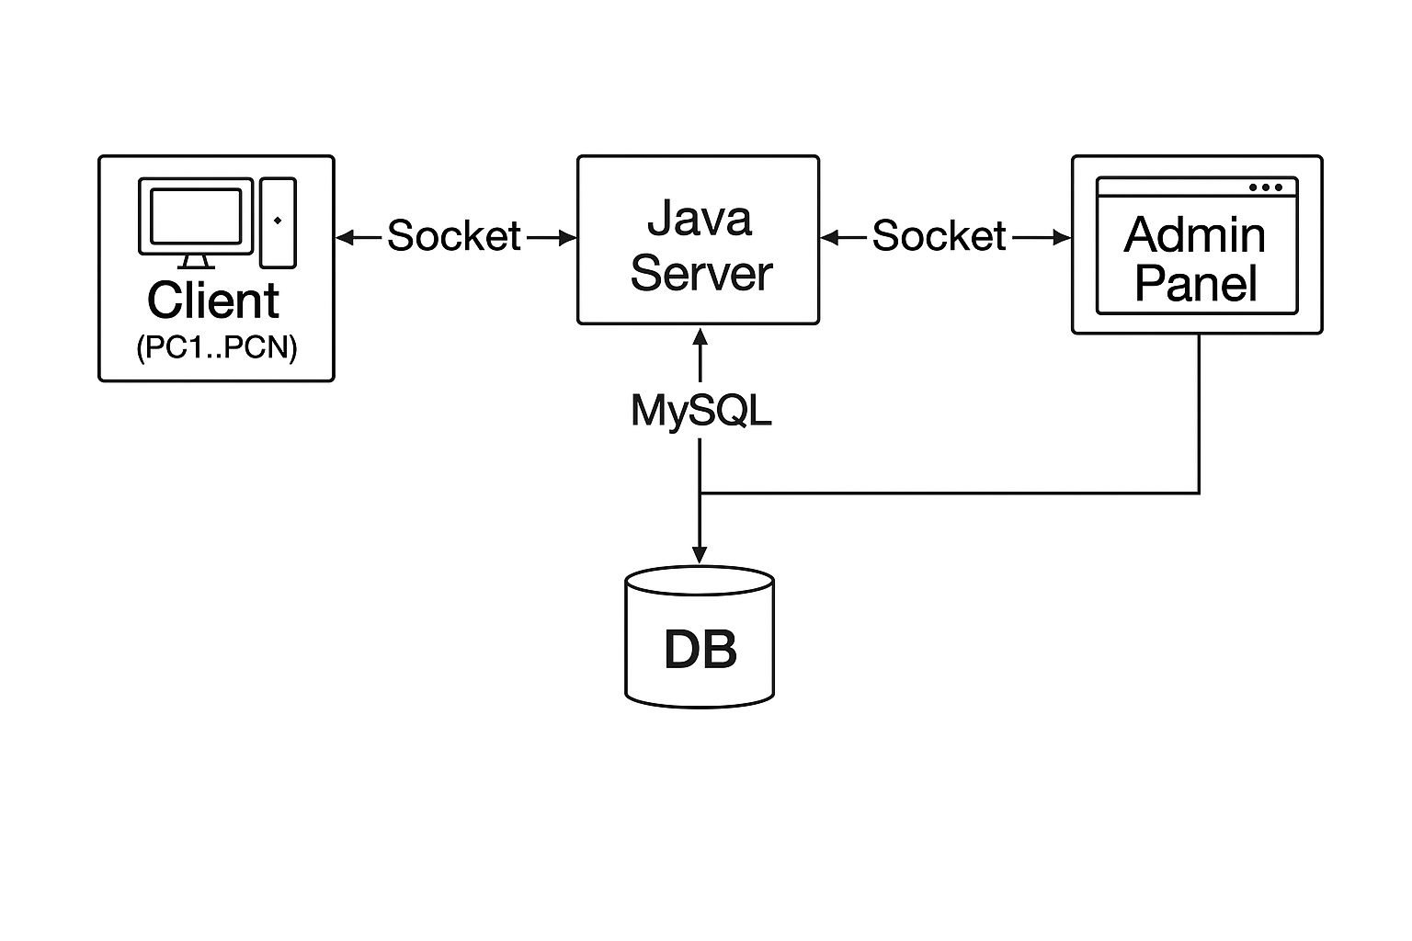

3. Features

Client-Side
- Choose preferred PC and session package
- Session tracking and countdown timer
- Game advertisements slideshow
- Scrollable, categorized game cards (e.g., Popular, Latest)
- Time extension request form
- Game launcher integration

Admin-Side
- Dashboard listing all PC statuses in real time
- FlowPane view of time requests with Accept/Decline
- Remote PC unlocking
- Track active sessions and auto-end them
- Manage and monitor multi-client connections
- Have full control to customize their profile

Database
- users table for login and profile info
- game_sessions for session logging
- time_requests for user requests
- games for listing available games
- pc_status for current states (locked, active, idle)

4. Workflow / How It Works
- Users have the flexibility to choose their preferred room, PC and package
based on their needs and preferences.
- Each PC presents a sleek game library while running eye-catching slideshow
ads- built for play and profit.
- Admin can remotely activate the PC selected by the customer for seamless
access.
- Server stores the session start time and notifies admin.
- If more time is needed, user requests an extension via UI.
- The server efficiently routes user requests to the admin for processing and
response.
- Admins can view incoming requests directly on the dashboard and allowing them to approve or reject with a single click.
- Server handles the command and updates both client and database.
- When the user finishes, the session ends, and the server logs it.

5. Technologies Used
- Java 17+ (Core programming language)
- JavaFX / FXML (UI development)
- Scene Builder (FXML layout design)
- MySQL (Backend database)
- Socket Programming (For real-time client-server communication)
- NetBeans (IDE)

6. Charts

6.1 Admin’s Chart

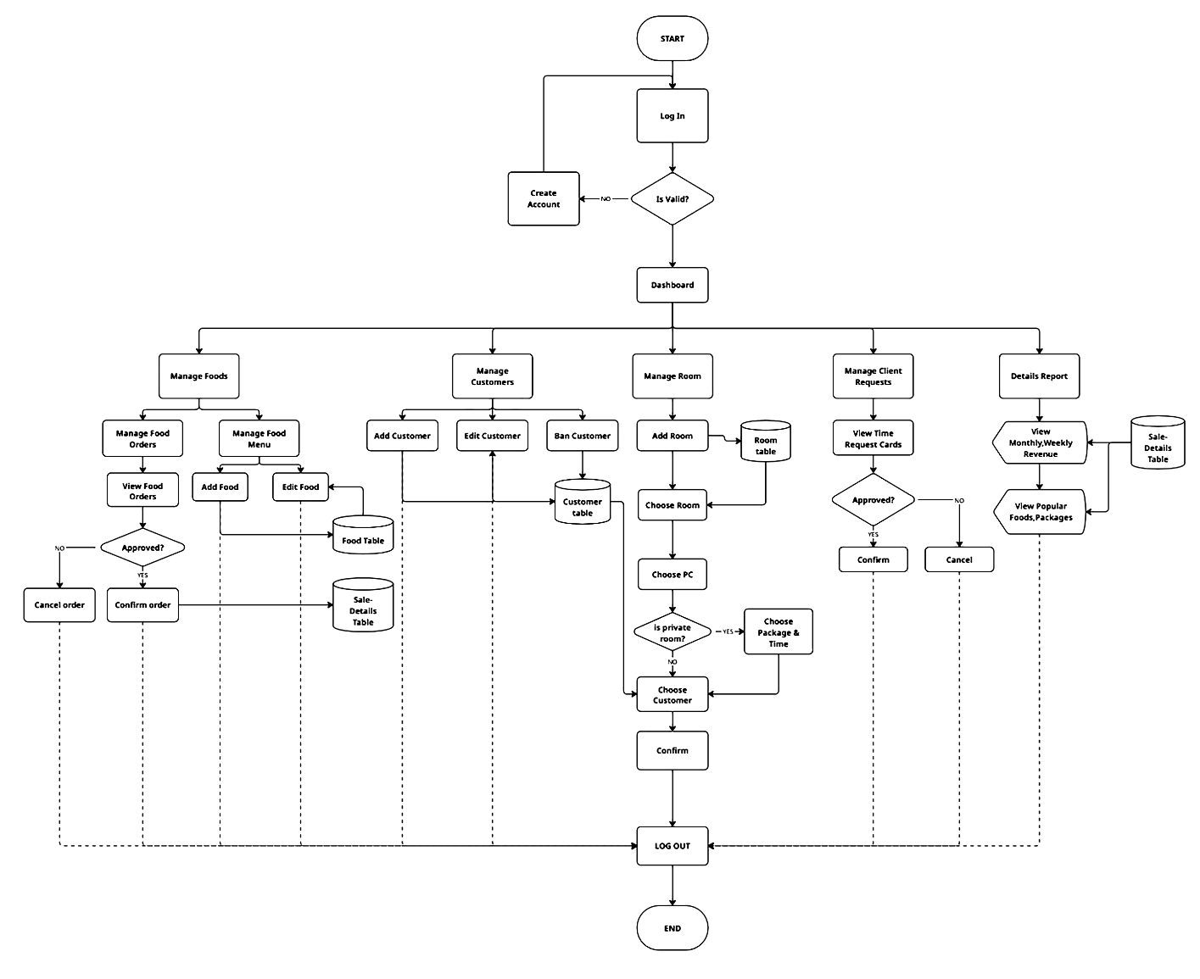

6.2 Client’s Chart

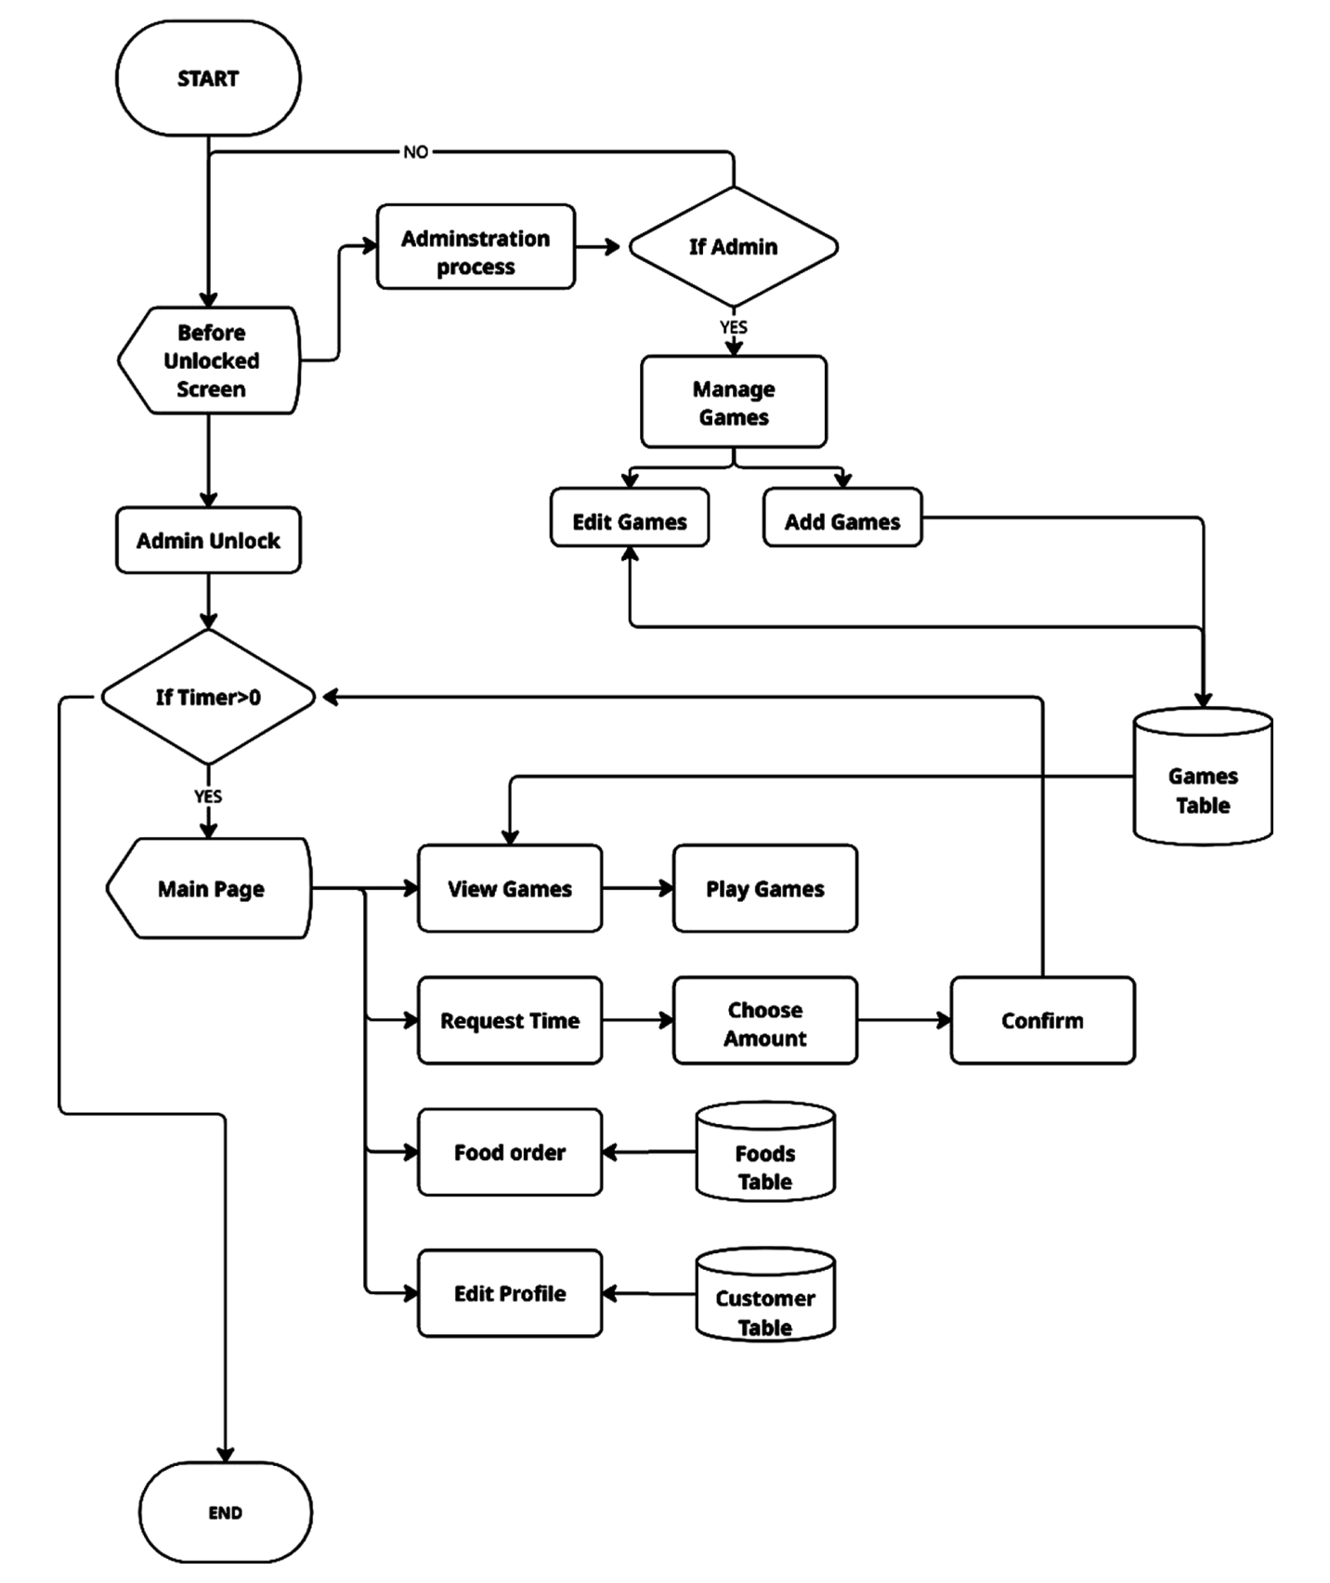

6.3 ER Diagram
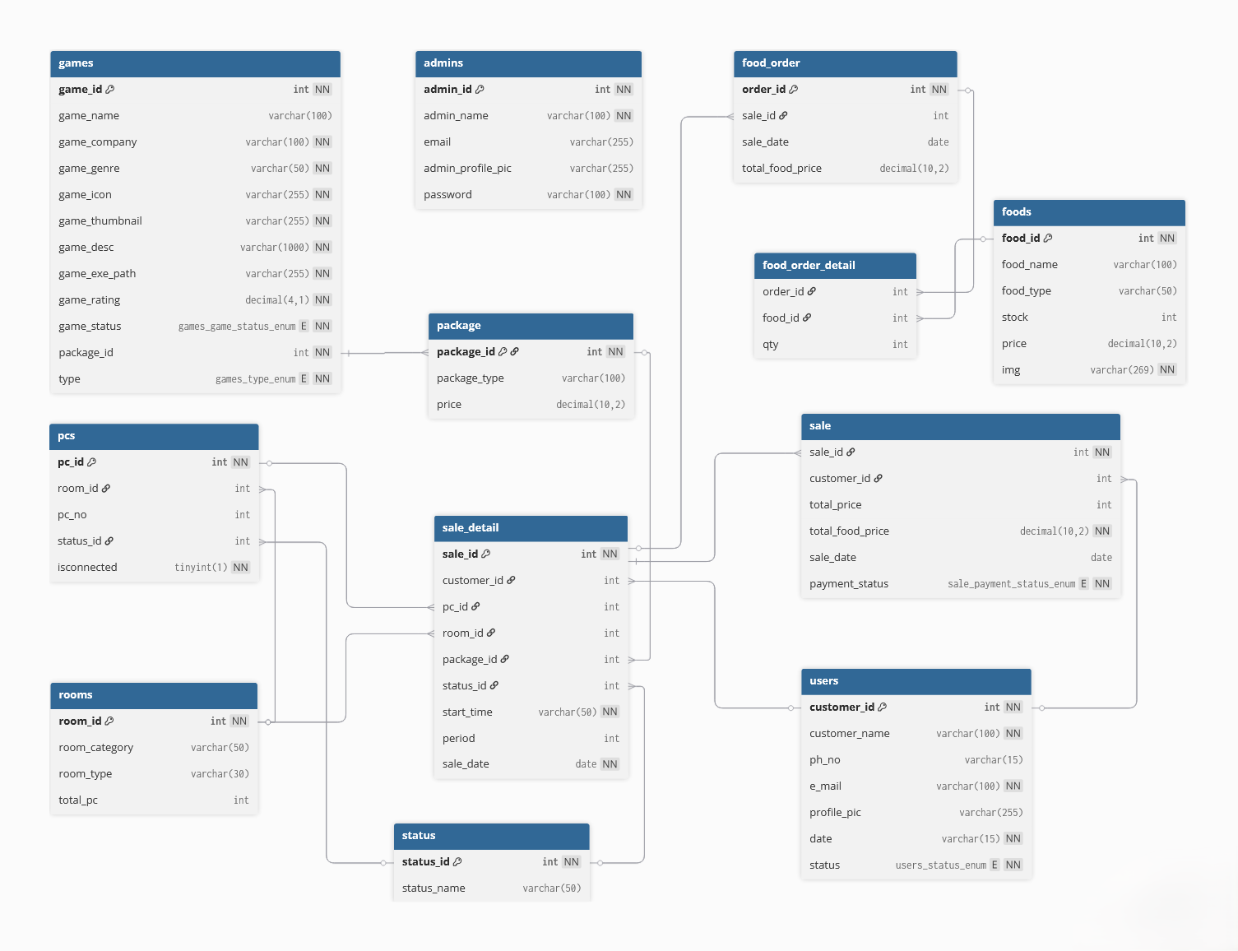
6.4 Use Case Diagram
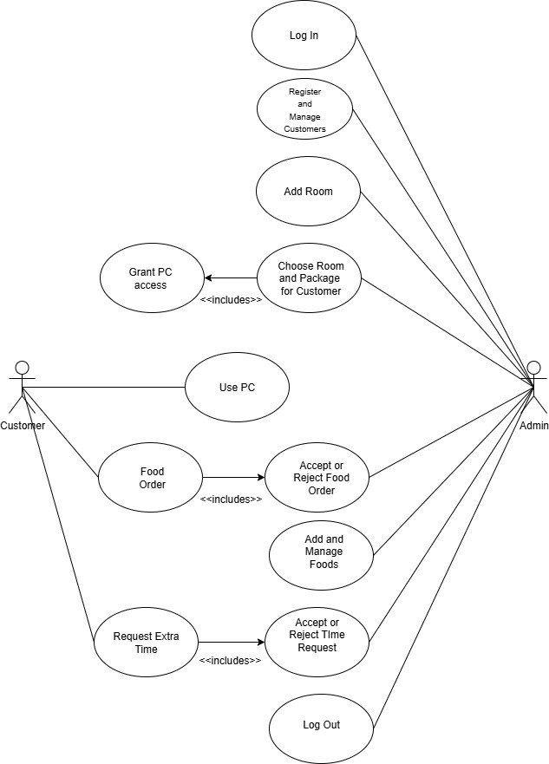
6.5 UI Admin & Client View
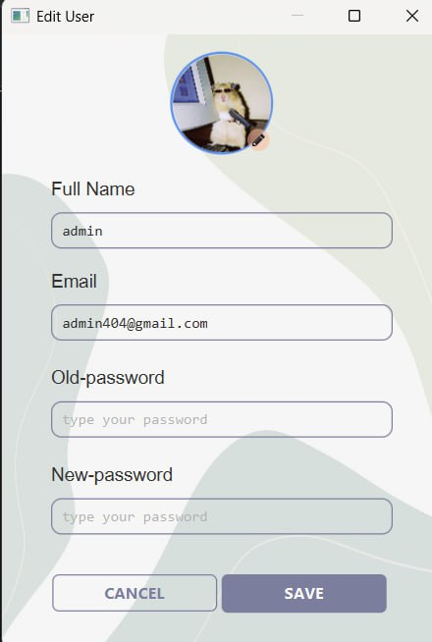

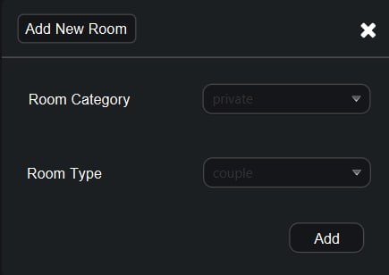

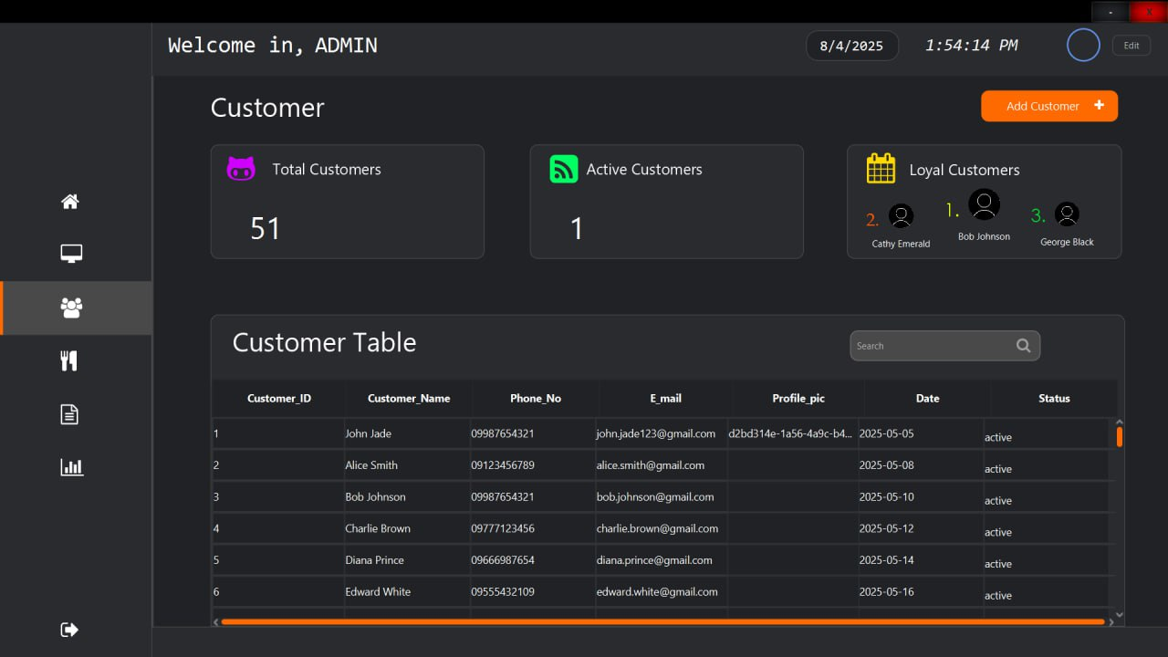

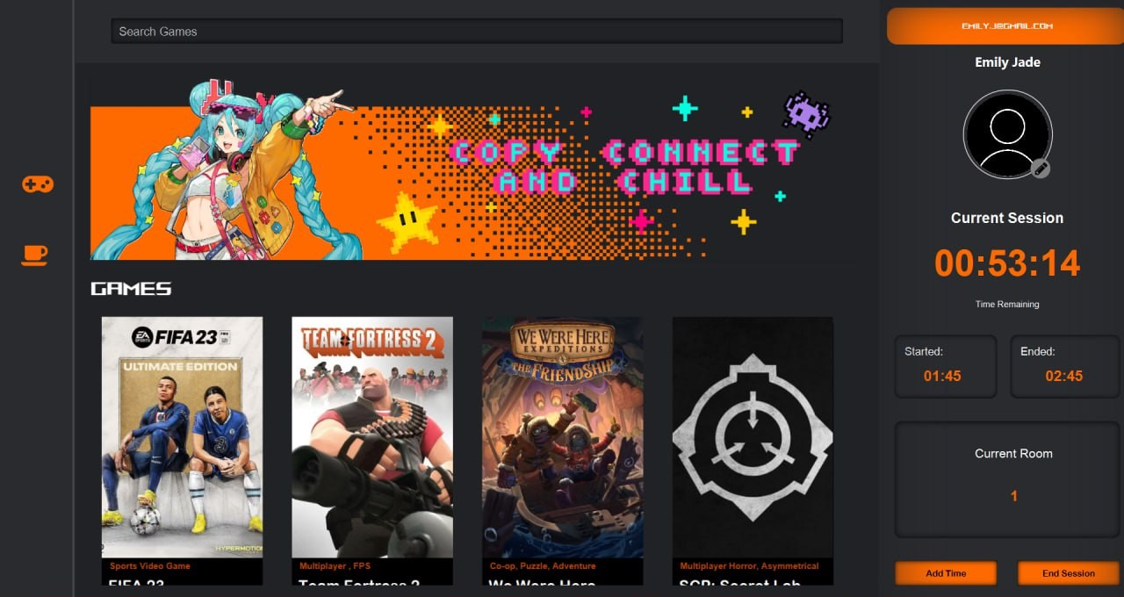

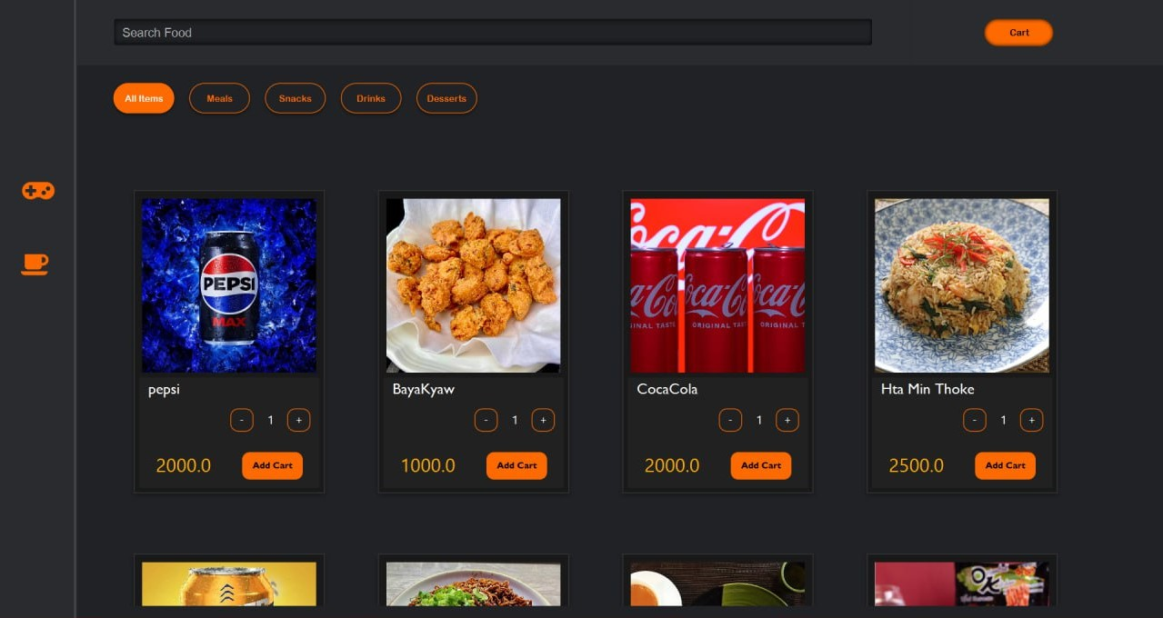

7. Strengths (Pros)
- Real-time, bi-directional communication
- Clean separation between client, admin, and server
- Easy-to-use interface for both users and admin
- Flexible and extensible codebase
- Profile panel improve UX
- Reduces manual workload for staff
- Can conveniently order food directly from their gaming station with a single click

8. Limitations (Cons)
- Performance can drop with many FXML cards (e.g., PC load screen)
- Socket server is LAN-only unless port forwarding or remote support is added
- UI syncing across controllers can be tricky without proper refactoring
- Lack of role-based access control, as it does not distinguish between privileged users and regular users
- The system cannot associate or preserve their game progress

9. Challenges Faced
- Smooth handling of multiple dynamic FXML loading
- Ensuring HashMap and socket channels sync with UI states
- Avoiding duplicate listeners and memory leaks in JavaFX
- Keeping real-time updates accurate without delay
- Designing the project to be extensible for future command types

10. Future Improvements
- Add cloud admin support
- Introduce user avatars and profiles with display pictures
- Game launcher with install detection and download manager
- Activity analytics and printable session logs
- Mobile version of admin panel
- Voice or chat support between client and admin
- Payment integration for auto-lock on unpaid sessions
- Cleaner MVC-based folder structure for maintainability

11. Conclusion
This Internet Café Management System offers a modern, real-time solution for managing an internet café, combining the flexibility of JavaFX UIs with the robustness of socket communication and database support. With clear roles, powerful admin tools, and an enjoyable client experience, the system bridges the gap between user comfort and administrative control. While the current version handles all essential tasks efficiently, it also provides a strong foundation for future enhancements and scalability.

